SEQUENCE DIAGRAM: MƯỢN SÁCH
sequenceDiagram
actor Student
participant LibrarySystem as Library System
participant Database

Student ->> LibrarySystem: login()
LibrarySystem ->> Database: verifyUser()
Database -->> LibrarySystem: valid
LibrarySystem -->> Student: login OK

Student ->> LibrarySystem: searchBook()
LibrarySystem ->> Database: queryBook()
Database -->> LibrarySystem: book list
LibrarySystem -->> Student: showBooks()

Student ->> LibrarySystem: selectBook()
LibrarySystem ->> Database: checkStatus()
Database -->> LibrarySystem: available

Student ->> LibrarySystem: confirmBorrow()
LibrarySystem ->> Database: saveBorrow
Database -->> LibrarySystem: saved
LibrarySystem -->> Student: borrowSuccess()
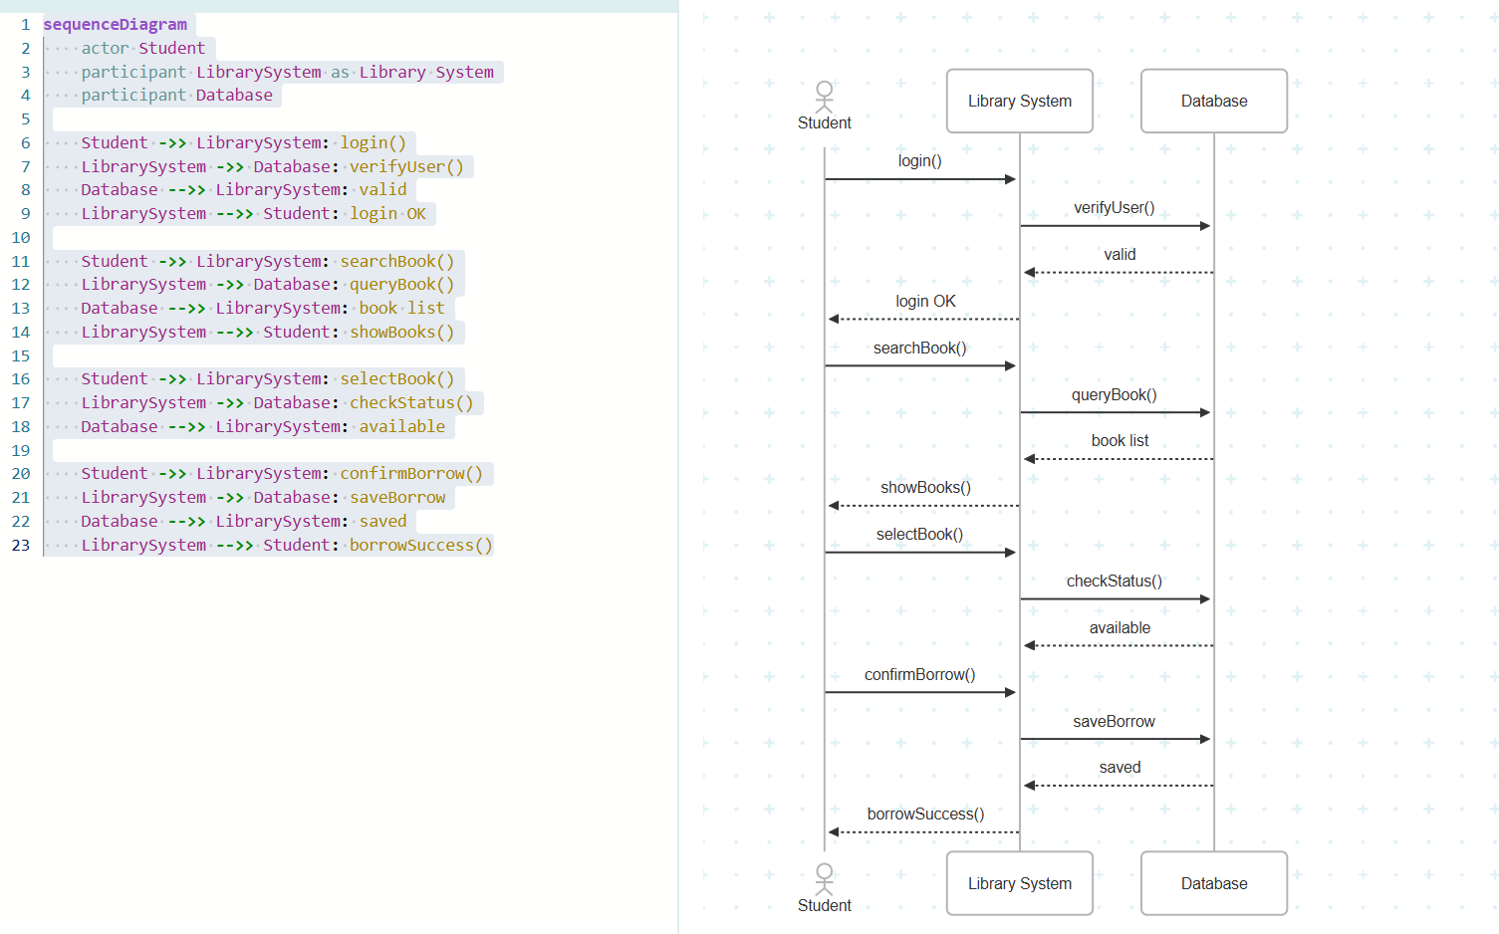

SEQUENCE DIAGRAM: TRẢ SÁCH
sequenceDiagram
actor Student
participant LibrarySystem as Library System
participant Database

Student ->> LibrarySystem: login()
LibrarySystem ->> Database: verifyUser()
Database -->> LibrarySystem: valid
LibrarySystem -->> Student: login OK

Student ->> LibrarySystem: returnBook()
LibrarySystem ->> Database: checkBorrow()
Database -->> LibrarySystem: borrowInfo

LibrarySystem ->> Database: checkOverdue()
Database -->> LibrarySystem: no overdue

LibrarySystem ->> Database: uopdateStatus()
Database -->> LibrarySystem: updated
LibrarySystem -->> Student: returnSuccess()
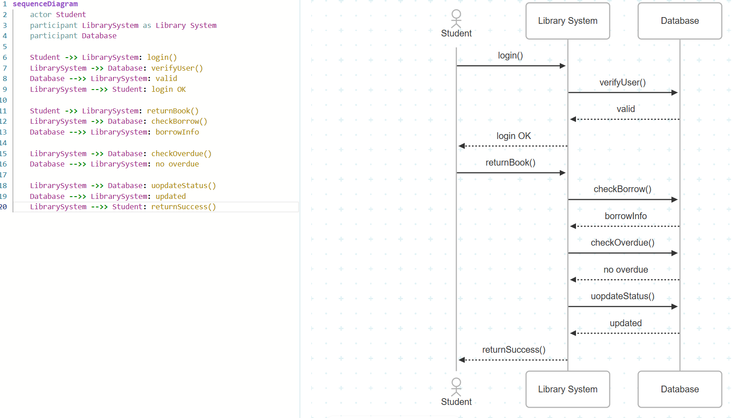

SEQUENCE DIAGRAM: THỦ THƯ QUẢN LÝ SÁCH
sequenceDiagram
actor Librarian
participant LibrarySystem as Library System
participant Database

Librarian ->> LibrarySystem: login()
LibrarySystem ->> Database: verifyUser()
Database -->> LibrarySystem: valid
LibrarySystem -->> Librarian: login OK

Librarian ->> LibrarySystem: manageBook()
Librarian ->> LibrarySystem: add/update/del
LibrarySystem ->> Database: saveBook()
LibrarySystem -->> Librarian: successMsg()

